SERMON AT FOR THE DIOCESE OF BUNBURY: GEOFF CHADWICK
24/2/2023: LENT1: THE YEAR OF DESERT RAIN

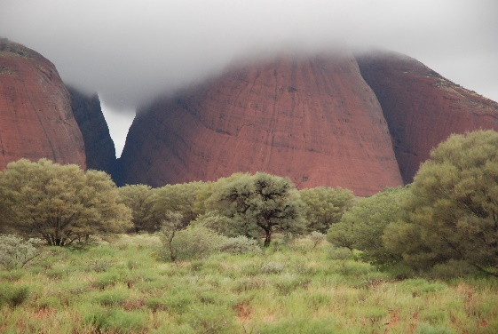
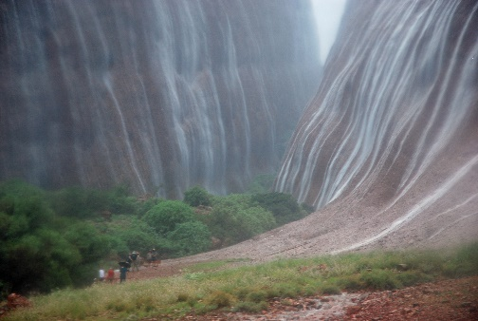
You may recall that a few year ago year there were record rains on Uluru (Ayres Rock) in January. Lucky for Gabby and me, we were there the week after and experienced our own drenching in the desert whilst hiking through the mysterious valley of Kata Tjuta (The Olgas). Given the opportunity of a quick holiday away, our travel agent arranged a “red-centre” experience for us. Little did we know that it would become a “green-centre” experience. A flight to Alice Springs saw us dining at Lasseter’s Resort, soaring over the desert in a hot air balloon, being entertained by the locals after Geoff had got into cheeky banter with a tour guide, walking up Kings Canyon where Pricilla Queen of the Desert had done so many years before wearing high heels and a ball gown, and scouring the bush for any hint of the nocturnal animals hidden away from the heat of the day. We also celebrated a significant wedding anniversary at the time with a five-star meal out amongst the desert “lights” and the glowing moon. In the midst of all this desert activity the highlight was the drenching rain at Kata Tjuta. Storm clouds, mist and rain rolled in over us as we ascended the hiking track between the great mounds. Suddenly we found ourselves surrounded by hundreds of waterfalls cascading down the thirsty canyon walls. For a short moment I wondered if we might get caught in a serious flood but the beauty overtook me as the ancient water courses began to drain the water away safely. These were more than springs in the desert, but torrents of hope to the thirsty land. Drenched, we were, not only by water, but by an overwhelming sense of awe.

This, I think, could be our metaphor for this season of Lent.

Maybe recent times have been a bit like the harsh red-centre of our land. Maybe you’ve had a few graces come your way: little patches of green in an otherwise barren landscape. Maybe you’ve been drenched by a sudden yet unexpected sense of God’s overwhelming grace to you. Desert rain, to keep you nourished in the thing we call life. Whatever the case, year after year the season of Lent invites us to persevere through the many aspects of our lives. Whether they be ‘red centres” or “drenching drains.” Lent invites contemplation.

And so, we are reminded of Jesus’ own “red-centre” experience. Taken into the wilderness for forty-day s of temptation. Wilderness yes, but not totally abandoned. Wild beasts and angels would be there as his graces, as his points of perseverance.
I hope you had the opportunity to engage in the ancient Ash Wednesday ritual of being anointed with ash. During that ritual we are reminded that we are “dust and to dust we shall return”. Not as some fascination with morbidity, but to remind us that life is worth living and what we do matters. And here’s a thought– as we have survived the desert before we might have a few clues for those who’ve never been there ….

Here are the word to a song called Desert Rain. That are particularly apt for today’s service.

DESERT RAIN:
Words and Music by Neil Hendry: 1988

See the desert rain
falling on the parched terrain
feel it quenching
see it drenching all the dust away.

See the earth transform
from the death new life is born
watch it sprouting
hear it shouting to the joyous day.

Can’t you feel the Spirit flowing
watering the seeds God’s sowing
Soon you’ll find your Spirit flowing free.

Feel the Spirit rain
falling on your heart again
bringing healing
gently filling up your life.

